**Name :Mohamed Sall Group :A1**

**SAE1.05 :Traitement de données**

**Instructions for use program :**

This notice will allow us to better use the python program.

You have to install a suitable environment for the python language for example Spyder .

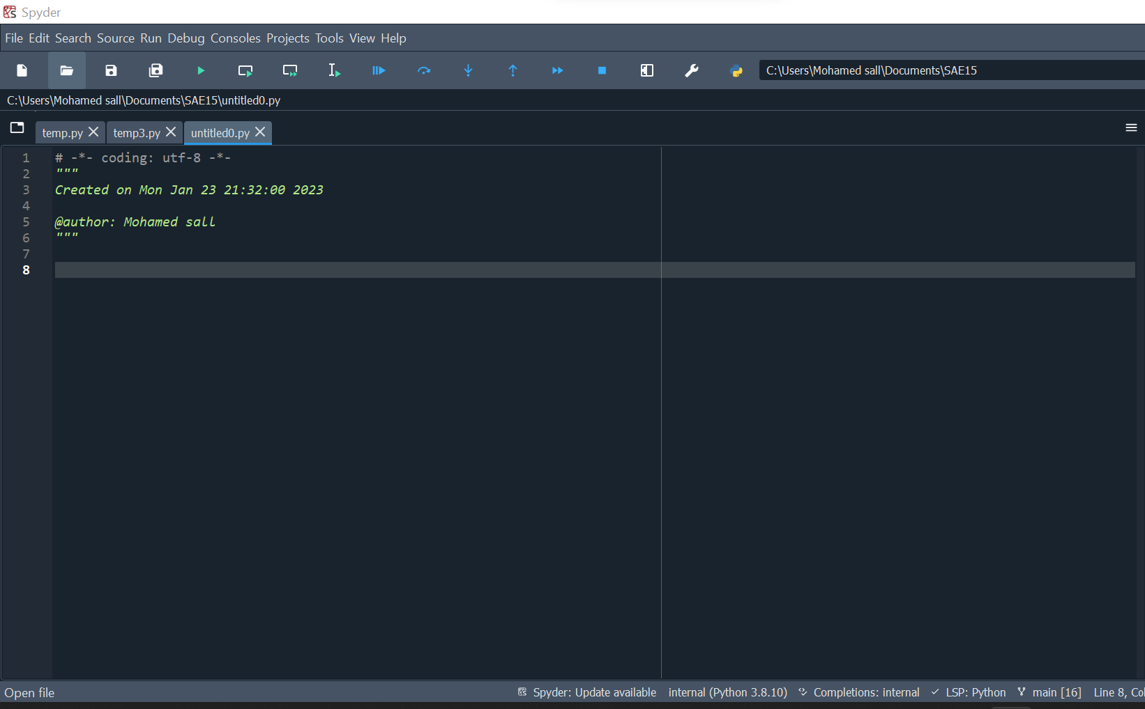

**Detailed explanation of the code :**

-Here we have imported the necessary libraries to process data with Excel and to represent them with a graph under python without forgetting the display on web page.

Import webbrowser for the web page/ import matplotlib.pyplot as plt for the graphs in Python/Import csv for transformation to csv file/Import numpy as np for tables or counters…

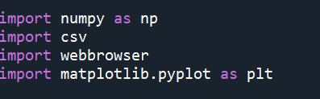

-We have here a piece of code that allows to open a file . In addition , it create lists and counters on the information coming from the tcpdump command(ipsrc,ipdest,seq….) .

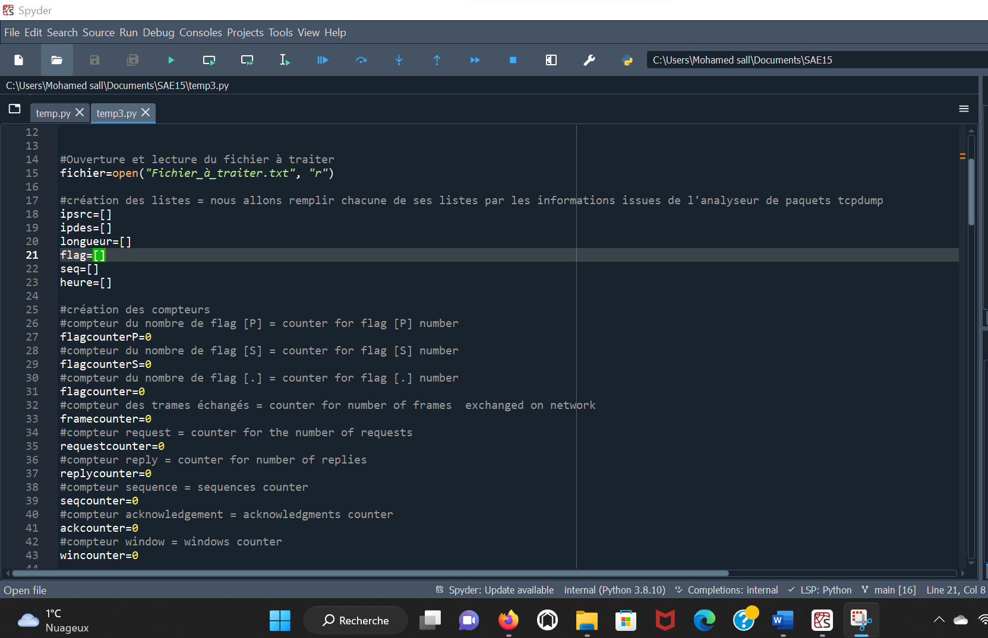

-This code show the filling of each list . However , we put a delimiter and the condition of filling depends on information. We can see the difference.

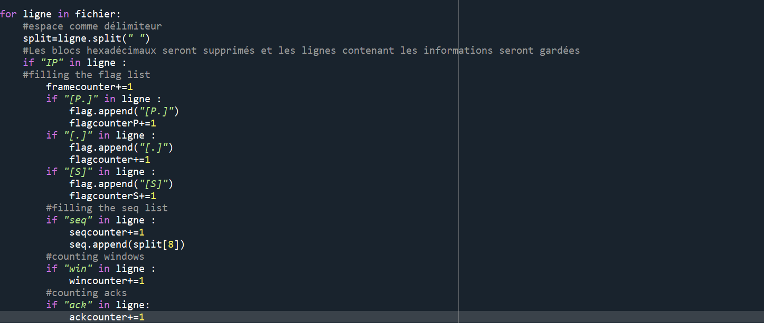

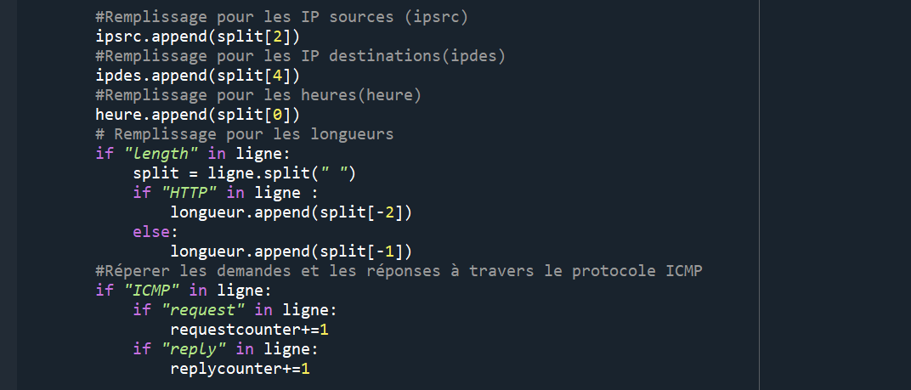

-This part of the code illustrates the transformation of counters into lists to view them on a csv file that we will open with excel.

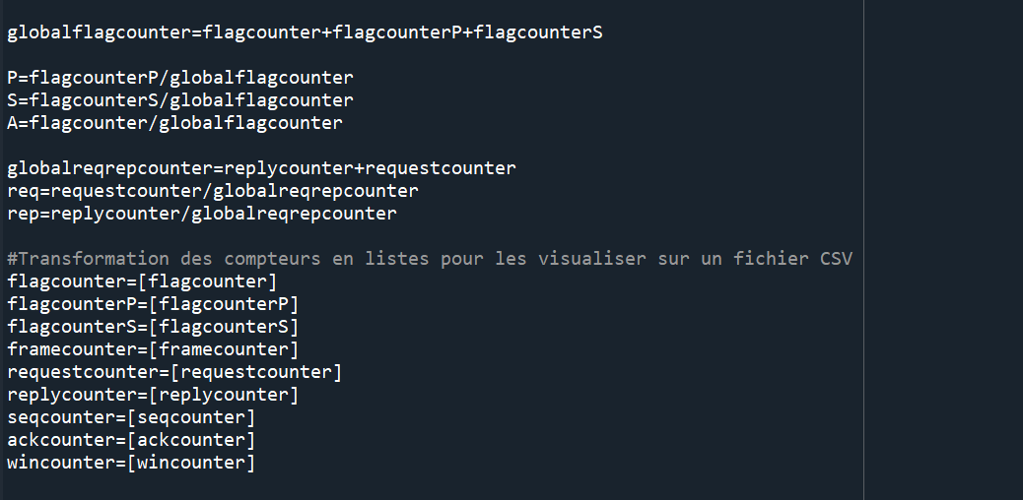

- This part shows the code that generates circular graphs in python and saves them.

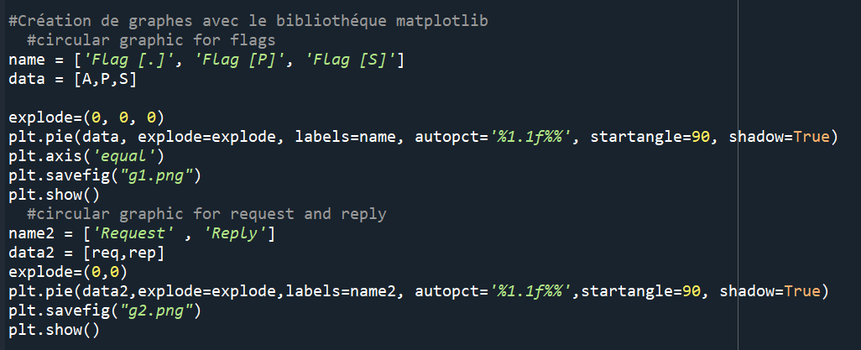

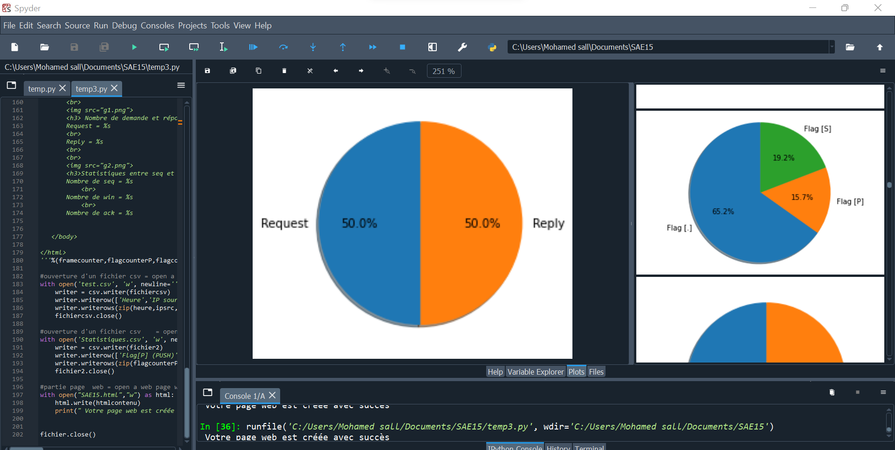

-This is the web page code. We have created this page to represent the results obtained by integrating the graphs (g1.png & g2.png) .

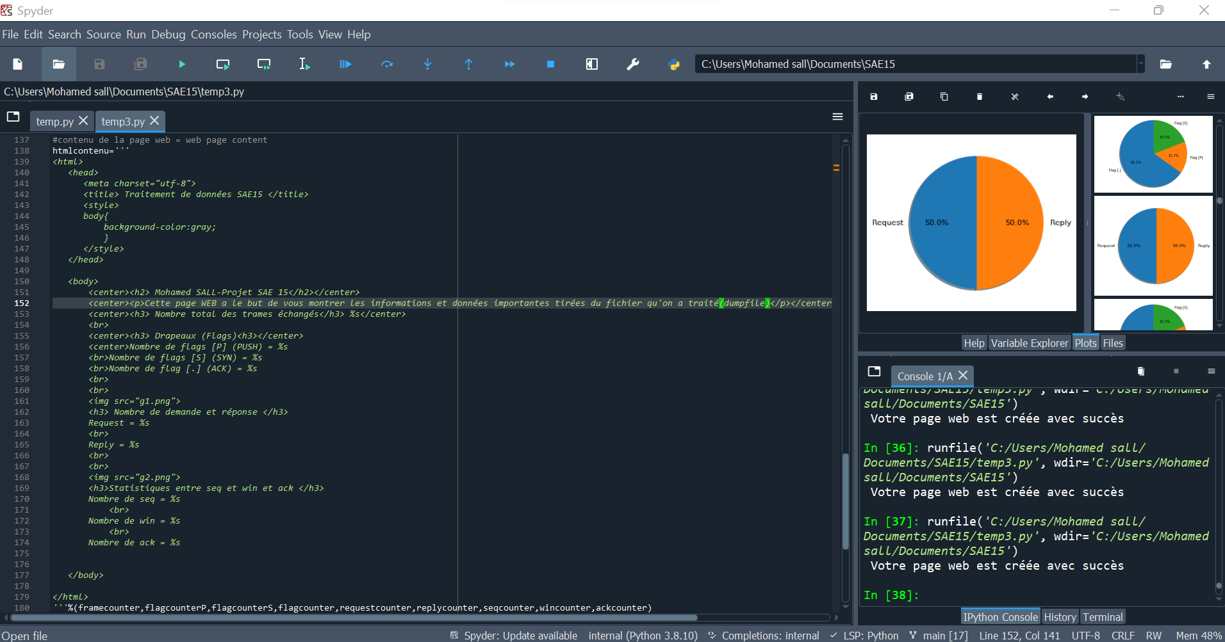

Here is the web page :

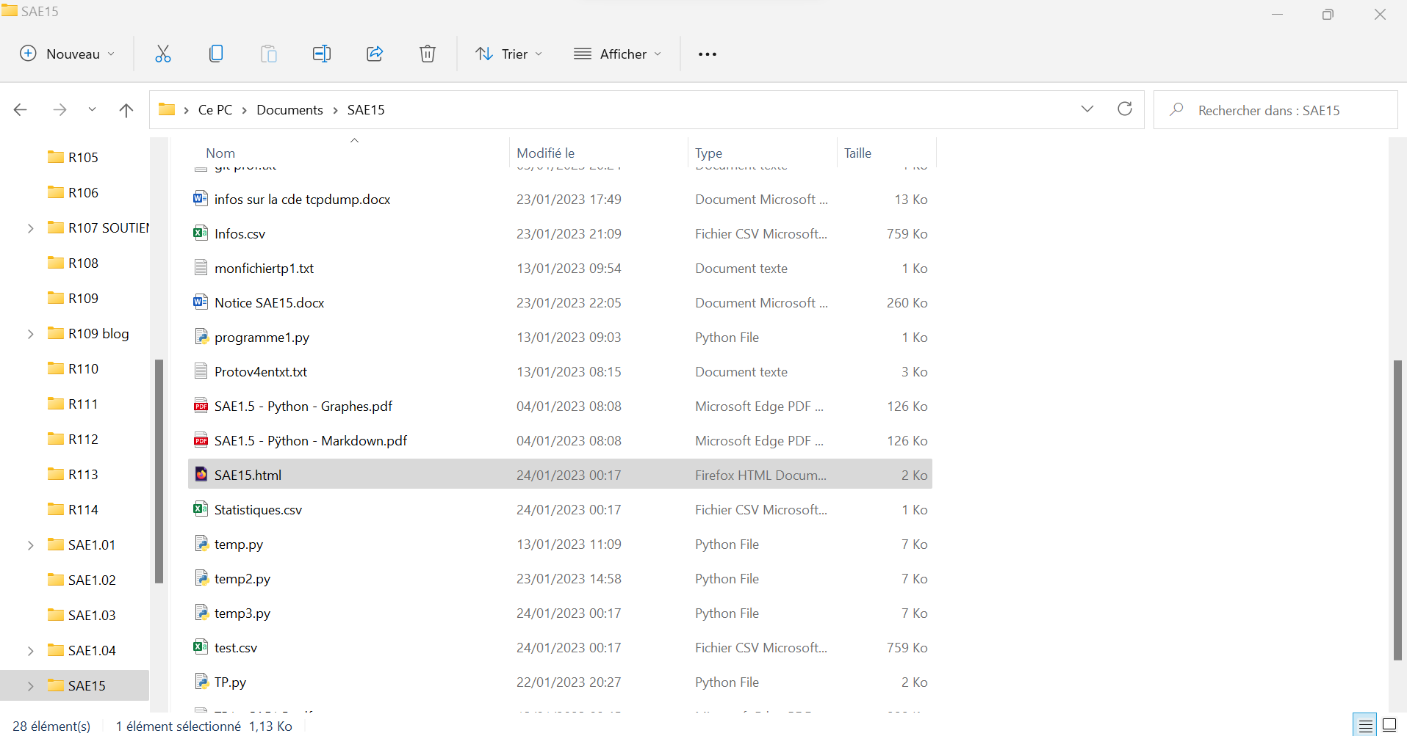

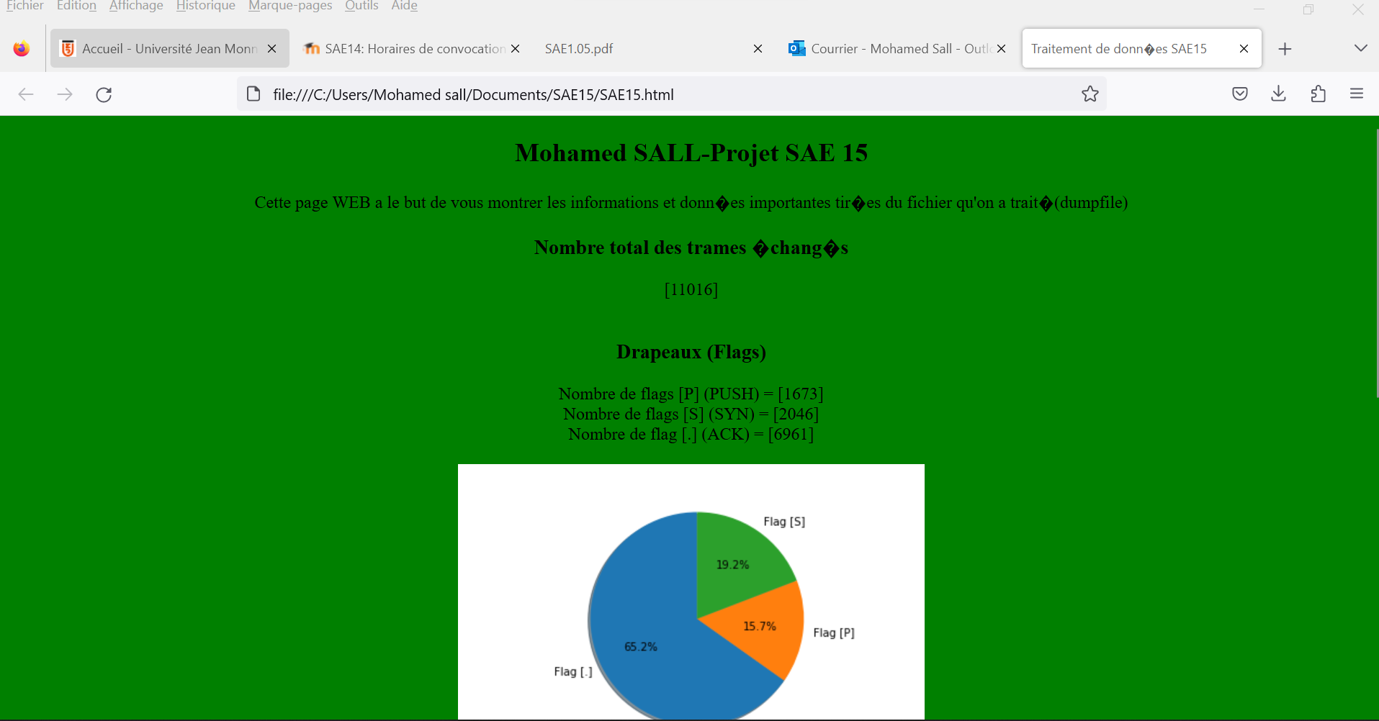

-This piece of code create two csv files . The most important is test because it give all the important information coming from tcpdump command

Normally, the program will be generate in our folder SAE15 :

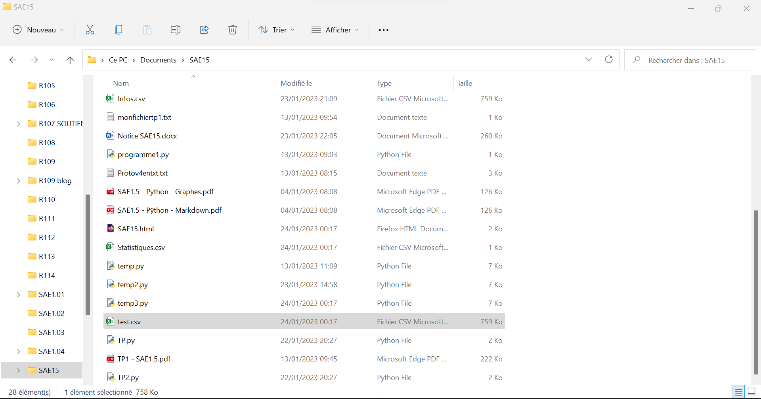

This file will be open by excel with the information

